­­­­­

|  |  |
| --- | --- |
|  |  |



Virual Plots usecase

**Solution Design   
Document**



Table of Contents

I. Purpose 3

II. Document History 4

III. Automated process details 5

2 Runtime guide 6

2.1 Architectural structure of the Master Project 6

2.2 Master Project Runtime Details 7

2.3 Project(s) workflows 8

2.4 Packages 8

2.5 Architectural structure of the Master Project 8

Other Details 9

Future Improvements 9

Other Remarks 9

Glossary 10

# Purpose



Outlines the major components of the Master Project (the overall output of the development, containing one or multiple projects that together cover the scope of the robotic process automation) taking into account all the business restrictions (scheduling, peaks, future increases in volume etc.). The focus of the Solution Architect will be on:

* Robustness;
* Scalability;
* Efficiency;
* Replicability;
* Reusability of component

The information herein is targeted primarily at the developers that will initially implement the solution and subsequently at the support developers in case of change requests.

# Document History

|  |  |  |  |  |  |  |
| --- | --- | --- | --- | --- | --- | --- |
| Date | Version | Role | Name | Organization/ Department | Function | Comments |
| 02 mar 2022 | 1.0 | Author | Vajrang | IT | Developer | Initial Draft |
|  |  |  |  |  |  |  |
|  |  |  |  |  |  |  |
|  |  |  |  |  |  |  |
|  |  |  |  |  |  |  |

# Automated process details

Details filled in need to reflect the actual information for the Master Project released for production. The following table will be populated:

|  |  |
| --- | --- |
| Item | Description |
| Project Name | VirtualPlots_DispPerformer |
| Robot Type | BOR, FOR or Mix |
| Is Background process?  (No click like UI interaction) | No |
| Orchestrator used? | Yes |
| Scalable | Yes |
| UiPath version used | 21.10.5.0 |

# Runtime guide

## Architectural structure of the Master Project

Display the interaction between components (package / robots, Orchestrator queues, and running order) in a diagram

## Master Project Runtime Details

Outlines the details of the automated process by filling in the table below.

|  |  |
| --- | --- |
| ITEM NAME | DESCRIPTION  *Fill in each bolded section - empty fields are not allowed. If the section does not apply to your automation then mark as n/a.* |
| Production environment details | ***Running on Azure, Windows 11 Virtual machine***  ***Triggered on queue item*** |
| Prerequisites to run | ***Input excel must be downloaded with all information***  *Having Excel on the machine* |
| Input Data | *1 valid excel files*  *2 source files in Data/Input* |
| Expected output | *3 e-mails sent to buyer and purchaser e-mail address:* [*management@abc.com*](mailto:management@abc.com) *and registrationoffice* |
| How to start the automated process | ***1 valid excel file*** |
| Reporting (queues reporting, Kibana, Excel or another platform) | ***Daily reporting with executions on that day*** |
| How is Orchestrator used? | ***Example:*** *The process will be started from orchestrator server*  *https://cloud.uipath.com/vajraqcqdotn/* |
| Password policies (mention any specific compliance requests) | ***No Password****.* |
|  |  |
| Stored credentials  (Never use hardcore credentials in the workflow!) | ***No Credentials*** |
|  |  |
| List of queues names | ***VirtualPlots****_Queue* |
| Schedule Details | *Daily, 6 A.M CET* |
| Multiple Resolutions Supported?  (in case of image automation / Citrix and VDI) | ***No*** |
| Recommended Resolution | ***Example:*** *1920*1080* |
| Scalable | ***Example:*** *Yes* |
| Environment used for development  (name, location, configuration details etc) | ***Example:*** *DEV_Env1_EMEA ( VM computer)* |
| Environment prerequisites  (OS details, libraries, required apps) | *Windows 11, BackOffice&Studio license, Microsoft Excel* |
| Repository for project  (where is the developed project stored) | *https://github.com/vajrang-b/RPA-Developer-in-30-Days* |
| Configuration method  (assets, excel file, Json file) | ***Example:*** *Assets* |
| List of reused components | ***Example:*** *found via MyGo!* |
|

## Project(s) workflows

For the workflow files defined below please specify the input and output parameters.

|  |  |  |
| --- | --- | --- |
| Workflow file | Arguments | Description |
| Dispatcher | ienu_NewQueueItems  InputFilePath  dt_TransactionData | Get all new items from queue  Excel path that is download  Data read from excel |
| Main | in_OrchestratorQueueName  in_OrchestratorQueueFolder |  |
| CloseAllApplications |  |  |
| GetTransactionData | in_TransactionNumber  in_Config  out_TransactionItem  out_TransactionField1  out_TransactionField2  out_TransactionID  io_dt_TransactionData |  |
| InitAllApplications | in_Config |  |
| InitAllSettings | in_ConfigFile  in_ConfigSheets  out_Config |  |
| KillAllProcesses |  |  |
| Process | in_TransactionItem  in_Config |  |
| RetryCurrentTransaction | in_Config  io_RetryNumber  io_TransactionNumber  in_SystemException  in_QueueRetry |  |
| SetTransactionStatus | in_BusinessException  in_TransactionField1  in_TransactionField2  in_TransactionID  in_SystemException  in_Config  in_TransactionItem  io_RetryNumber  io_TransactionNumber  io_ConsecutiveSystemExceptions |  |
| TakeScreenshot | in_Folder  io_FilePath |  |
| GeneralTestCase | in_WorkflowFile  in_ExpectedResult |  |
| GetTransactionDataTestCase |  |  |
| InitAllApplicationsTestCase |  |  |
| InitAllSettingsTestCase |  |  |
| MainTestCase |  |  |
| ProcessTestCase |  |  |
| WorkflowTestCaseTemplate |  |  |

## Packages

Include the list of packages and high-level description for each of them, to explain their purpose

|  |  |
| --- | --- |
| Package Name | Description |
| UiPath.Excel.Activities : [2.11.4] |  |
| UiPath.System.Activities : [21.10.4] |  |
| UiPath.Testing.Activities : [1.4.6] |  |
| UiPath.UIAutomation.Activities : [21.10.5] |  |
| UiPath.WebAPI.Activities : [1.9.2] |  |

## Architectural structure of the Master Project

Display the interaction between components (package / robots, Orchestrator queues, and running order) in a diagram.



# Other Details

### Future Improvements

Fill in any improvements that need to be considered for the future:

***Example:***

*• Optimize the processing algorithm*

*• Implement process error recovery (retry)*

*• Enable support for multiple template files*

### Other Remarks

Please mention here any other points that you consider relevant for the automation process.

***Example:*** *The workflow should run every night at 7AM. Be careful not to schedule it before the report is generated by X system.*

The system generated data is always 1 day old.

# Glossary

The main terms used in the Solution Architecture Document are defined below:

**Master project** - the overall output of the development, containing one or multiple projects that together cover the scope of the robotic process automation. There is a 1 to 1 connection between the Master Project and the Process to be automated (As presented in the PDD).

**Project** - an UiPath Studio project containing one or multiple workflow files. A project can be converted to a package and run independently, covering a particular scope within the master project. Or multiple projects can be converted into one package depending on the aims and restrictions of the automation. The project is used when defining the development and support phase of the automation.

**Package** - the output of compiling one or multiple projects. A package can be deployed on the robot machine and be executed by the robot service. Only one package can be executed at a given time by a robot. The package is used when defining the running phase of the automation.

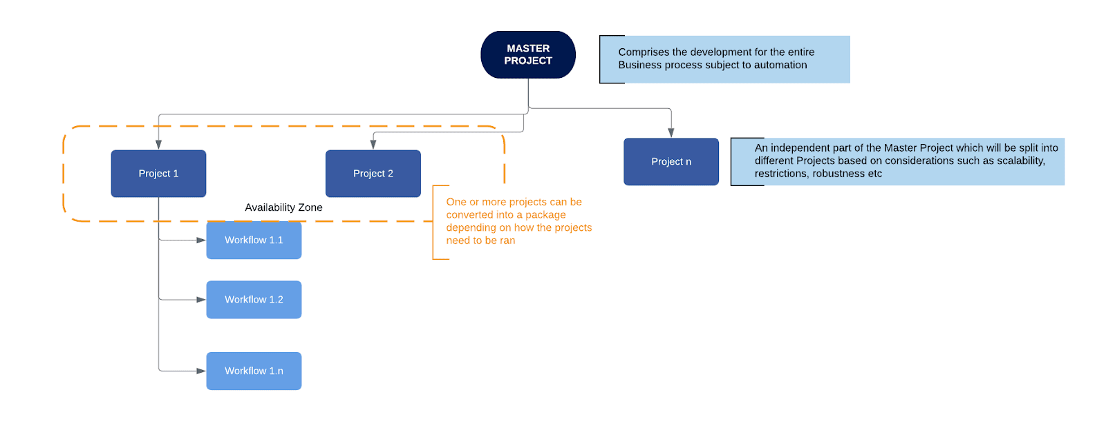Workflow - a component of the package, the workflow encapsulates a part of the project logic. The workflow can be of type: sequence, flowchart or state machine. A workflow is saved as an .xaml file inside the project folder. A workflow file can be invoked from another workflow and by default there is an initial workflow file that will run when executing the package.

**Activity** - an action that the robot executes.

**Sequence** - a workflow where activities are executed one after another, in a sequential order

**Flowchart** - a workflow where activities are connected by arrows and the logic of the workflow can be easily followed in a visual manner. The flowchart can also be exported as an image from UiPath studio.

**State machine** - a more advanced way of organizing a workflow, similar to a flowchart.

**BOR** - Back office robot

**FOR** – Front office robot

**Orchestrator** – Enterprise architecture server platform supporting: release management, centralized logging, reporting, auditing and monitoring tools, remote control, centralized scheduling, queue/robot workload management, assets management.